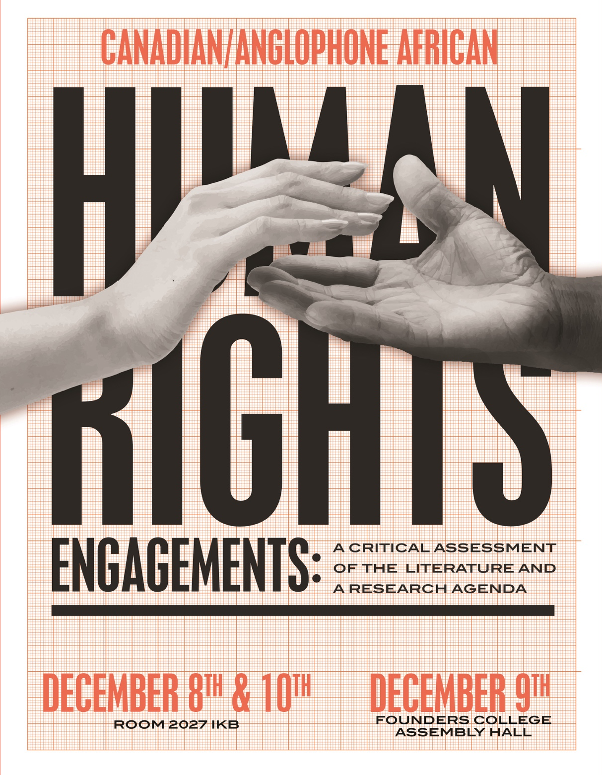

Osgoode Hall Law School
York University
4700 Keele Street
Toronto, ON M3J 1P3
© 2016

Thursday 8th December 2016
Venue: Faculty Common Room (Room 2027), Ignat Kaneff Building

8.30 am - 9.30 am Breakfast
Room 2027 Ignat Kaneff Building

9.30 am - 10.30 am Opening Remarks/Announcements
Professor Francois Tanguay-Renaud
Director of the Jack and Mae NATHANSON CENTRE on Transnational Human Rights, Crime and Security

Professor Obiora Okafor
Conference Convenor, Professor & York Research Chair in International and Transnational Legal Studies, Osgoode Hall Law School

Mr. Okey Kalu
Conference Coordinator, PhD Candidate, Osgoode Hall Law School

Session I: Canada in the African Human Rights World
10.30 am – 12.30pm Canada in Africa: An Overview of some Canadian Development Projects in West Africa (presentation via Skype)
Professor Olabisi Akinkugbe
Assistant Professor, University of New Brunswick

Threading a Fine Line: Canada and the Quest for Environmental Rights in Africa
Dr. Basil Ugochukwu
Post-Doctoral Fellow, Centre for International Governance Innovation

Discussants:
Dr. Nadege Compaore, SSHRC Postdoctoral Fellow, Department of Social Science, York University

Ms. Saratu Bissallah-Alao, Research Fellow, Nigerian Institute of Advanced Legal Studies

12.30 pm – 2.30pm Lunch
Room 2027 Ignat Kaneff Building

2.30 pm – 4.30pm Session II: Canadian Anglophone African Engagements in the Human Rights and Health Area
Reproducing Women’s Health Rights: Canadian-African Human Rights Engagement, Normativity, Indigeneity and the Spaces Beyond the (Norm Life) Cycle.
Professor Irehobhude Iyioha, PhD
Visiting Assistant Professor and Assistant Adjunct Professor, Faculties of Law and Medicine & Dentistry, University of Alberta.

Canadian/Anglophone African Human Rights Engagement: A Critical Assessment of the Literature on Health Rights
Mr. Uche Ngwaba
PhD Candidate in Health Law, Macquarie University, Sydney, Australia

4.30 pm – 5.30pm Session III: Concluding Discussions/Announcements
Professor Obiora Okafor
Conference Convenor, Professor & York Research Chair in International and Transnational Legal Studies, Osgoode Hall Law School

Mr. Okey Kalu
Conference Coordinator, PhD Candidate, Osgoode Hall Law School

***

Friday, 9th December, 2016
Venue: Founders College, Assembly Hall

8.30 am – 9.30 am Breakfast
Founders College, Assembly Hall

9.30 am – 11.00 am Session IV: Nigeria
Human Rights Discourses in Nigeria Across Time: Trajectory, Successes and Potentials for Foreign Engagement
Dr. Solomon Ukhuegbe
Senior Lecturer, University of Benin, Nigeria
In Search of Accountability: A Critical Assessment of the Literature on the Immunity of State Officials in International Law for Human Rights Violations
Dr. Udoka Nwosu-Owie
Senior Lecturer, Baze University, Nigeria

Canadian-Nigerian Co-Operation in the Area of Anti-Corruption, 1999-2011: Rhetoric and Substance
Professor Paul Ocheje
Associate Professor, University of Windsor

Discussants:
Dr. Opeoluwa Badaru, Critical Research Laboratory in Law & Society, Osgoode Hall Law School

Ms. Rahina Zarma, PhD Candidate, Osgoode Hall Law School

11.00 am – 1.00 pm Session V – South Africa/Botswana
Evaluating Canadian/South African Collaborative Human Rights Initiatives
Dr. Moses Phooko
Senior Lecturer, College of Law, University of South Africa

Canadian/Botswanan Human Rights Engagements: A Critical Assessment of the Literature and a Research Agenda
Dr. Ramadi Dinokopila
Senior Lecturer, University of Botswana, Gaborone, Botswana

Discussants:
Ms. Halima Doma Kutigi, Lecturer, Nasarawa State University, Keffi, Nigeria

Ms. Nkechi Eneh, Justice Ministry, Nigeria

1.00 pm - 3.00 pm Lunch
Founders College, Assembly Hall

3:00 pm - 5.30 pm Session VI – Zambia/Uganda
Canadian/Zambian Human Rights Engagements: A Critical Assessment of the Literature and Research Agenda
Ms. Misozi Lwatula
Lecturer, School of Law, University of Zambia

Canadian/Ugandan Human Rights Engagements: A Critical Assessment of the Literature and Research Agenda
Dr. Zahara Nampewo
Senior Lecturer, School of Law in Makerere University.

Discussant:
Mr. Okey Kalu, Conference Coordinator, PhD Candidate, Osgoode Hall Law School

5.30pm – 6.00pm Session VII: Concluding Discussions/Announcements
Professor Obiora Okafor
Conference Convenor, Professor & York Research Chair in International and Transnational Legal Studies, Osgoode Hall Law School

Mr. Okey Kalu
Conference Coordinator, PhD Candidate, Osgoode Hall Law School

***

Saturday 10th December 2016
Venue: Faculty Common Room (Room 2027), Ignat Kaneff Building

9.30 am - 10.30 am Breakfast
Room 2027 Ignat Kaneff Building

10.30 am - 12.30 am Session VIII – Ghana
Business & Human Rights in the Ghanaian Extractive Industry: The Quest for Corporate Accountability

Professor Uwafiokun Idemudia
Associate Professor, Department of Social Science, Faculty of Liberal Arts & Professional Studies, York University
&
Ms. Cynthia Kwakweyah
MA Candidate, Interdisciplinary Program at York University

A Critical Assessment of universalism, difference and cultural exceptionalism in Human Rights Discourse and Practice in Ghana
Professor Sylvia Bawa
Assistant Professor, Department of Sociology, Faculty of Liberal Arts & Professional Studies, York University

Discussant:

Professor Ibironke Odumosu-Ayanu, Associate Professor, College of Law, University of Saskatchewan

Professor Sirleaf, Matiangai, Assistant Professor of Law, University of Pittsburgh

12.30 pm - 2.30 pm Lunch
Room 2027 Ignat Kaneff Building

2.30 pm - 4.30 pm Session IX – Kenya/Tanzania
Canada's Human Rights Moments in Kenya's Constitutional Transformation AgendaProfessor Sylvia Kanga’ra
Professor of Law, University of Washington

Canada/Tanzanian Human Rights Engagements: A Critical Assessment of Literature and a Research Agenda
Ms. Julena Jumbe Gabagambi
PhD Candidate, Open University of Tanzania

Who Will Remember the Children? - The International Human Rights Movement and Juvenile Justice in Africa
Professor Faisal Bhabha
Associate Professor, Osgoode Hall Law School
&
Cristina Candea
JD/MA Philosophy, Law and Philosophy Candidate, Osgoode Hall Law School

Discussants:
Mr. Maxwell Miyawa, PhD Candidate, Osgoode Hall Law School

Mr. Jake Okechukwu Effoduh, LLM Candidate, Osgoode Hall Law School

4.30pm – 5.00pm Session X: Concluding Discussions/Announcements
Professor Obiora Okafor
Conference Convenor, Professor & York Research Chair in International and Transnational Legal Studies, Osgoode Hall Law School

Mr. Okey Kalu
Conference Coordinator, PhD Candidate, Osgoode Hall Law School

***

Join the conversation on Twitter: #CARRIAA
@CarriaaProject CarriaaProject

Canadian Anglophone African Human Rights Engagements www.carriaa.org
SSHRC: www.sshrc-crsh.gc.ca
Nathanson Centre: nathanson.osgoode.yorku.ca
Osgoode Hall Law School: www.osgoode.yorku.ca

